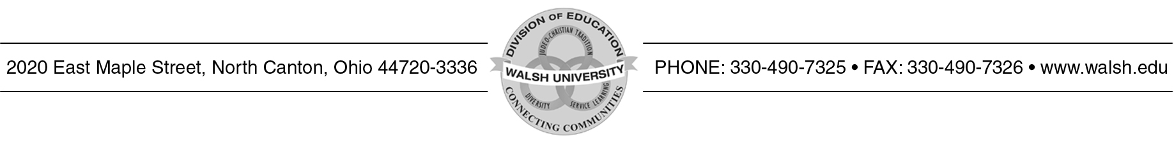

WALSH UNIVERSITY SUPERVISOR APPRAISAL (CLINICAL SEMESTER)

Name of University Supervisor

Name of Assessor Circle One: Cooperating Teacher / Teacher Candidate

Year Circle One: Fall Spring Today’s Date

Evaluation Guide:
3 = Supervisor is a role model who mentored and supported all aspects of the teacher candidate’s learning through classroom observations, held
conferences with both the cooperating teacher and candidate, and offered practical suggestions for improvement.

2 = Supervisor mentored and supported the teacher candidate learning through classroom observations, held conferences with cooperating teacher and candidate, and offered suggestions for improvement.

1 = Supervisor did not provide adequate support for the teacher candidate.

The Walsh University Supervisor: | 3 | 2 | 1
- Made clear what should take place during the clinical semester and his/her role
- Made clear the role of the cooperating teacher
- Made clear how the candidate is to assume the responsibility of teaching during the semester
- Collaborated with the cooperating teacher and candidate in arranging visitation times
- Observed the candidate a minimum of 5 times for a single placement and 5 times for a dual placement and discussed the observation with the candidate
- Discussed observations with the cooperating teacher
(either after the lesson or via email/phone)
- Assisted the candidate in improving skills through observation, analysis, and suggestions
- Monitored the candidate’s progress and problems with the cooperating teacher and/or other school personnel if applicable
- Completed the Mid-Term and Final evaluation forms and discussed them with the candidate and cooperating teacher
- Conducted him/her self in a professional and positive manner
The Walsh University Clinical Program:
- Was clearly presented in the Clinical Handbook
- Prepares candidates for entry-level teaching positions
Your Suggestions Are Valued! (please use back if needed)

The cooperating teacher should complete this form and return it to the supervisor in a sealed envelope.
The teacher candidate will complete this form during the seminar class.
Spring 2020

